**Mаthemаtical Modeling of Pollutant Trаnsport in the Tobol River**

**Student:**   
**Date:** April, 2025  
**Course:** Differential Equations, Prof. Sinitsa A.V.

**1. Introduction and Model Derivation**

***1.1 Problem Statement***

This report presents a mathematical model describing the transport and fate of pollutants in the Tobol River system. The Tobol River is a major tributary of the Irtysh River, flowing through Kazakhstan and Russia with a total length of approximately 1,591 kilometers. The river faces various environmental challenges due to industrial activities, agricultural runoff, and urbanization in its basin.

Our objective is to develop and analyze a one-dimensional diffusion-advection-reaction (DAR) model that simulates how pollutants diffuse, are transported by river flow, and decay through natural processes in this river system.

***1.2 Mathematical Model Formulation***

The one-dimensional diffusion-advection-reaction equation that governs the pollutant concentration in the river is:

∂C/∂t = D∂²C/∂x² - v∂C/∂x - kC + S(x,t)

Where:

* C(x,t) is the pollutant concentration at location x and time t [mass/volume]
* D is the diffusion coefficient [km²/day]
* v is the advection velocity (river flow speed) [km/day]
* k is the first-order decay rate [1/day]
* S(x,t) is the source term representing pollutant inputs [mass/volume·day]
* x is the distance along the river [km]
* t is time [days]

Each term in this equation represents a different physical process:

1. **Diffusion term** (D∂²C/∂x²): Represents the spreading of pollutants due to random molecular motion and turbulent diffusion
2. **Advection term** (-v∂C/∂x): Represents the transport of pollutants by the river flow
3. **Reaction term** (-kC): Represents the decay of pollutants through chemical or biological processes
4. **Source term** (S(x,t)): Represents external inputs of pollutants

***1.3 Model Parameters for the Tobol River***

Based on the comprehensive environmental analysis of the Tobol River, we selected the following parameters:

* **River length**: 1,400 km (simplified from actual 1,591 km for modeling purposes)
* **Diffusion coefficient (D)**: 15.0 km²/day (representing turbulent diffusion in river systems)
* **Advection velocity (v)**: 20.0 km/day (consistent with the mean annual discharge of 805 m³/s)
* **Decay rate (k)**: 0.1 day⁻¹ (representing first-order degradation processes)
* **Spatial discretization**: 100 points along the river length
* **Temporal domain**: 60 days with 120 time steps

**2. Creativity Component: Model Customization**

***2.1 River System Design***

Our model represents the Tobol River with the following custom features:

1. **Custom pollution input**: A point source pollution event located at 20% of the way downstream from the headwaters, representing a potential industrial discharge point. This is consistent with the environmental analysis identifying industrial facilities as point sources of pollution.
2. **Non-standard feature: Pulse pollution discharge**: Rather than a continuous discharge, we model a pulse pollution event lasting for 10% of the total simulation time (6 days). This represents a realistic scenario of an industrial spill or temporary failure of wastewater treatment facilities, which is more challenging to model than steady-state pollution.
3. **Realistic boundary conditions**:
   * Upstream boundary condition: Fixed concentration (clean water entering)
   * Downstream boundary condition: Zero gradient (concentration doesn't change at outlet)

***2.2 Incorporation of Real Tobol River Characteristics***

We incorporated actual characteristics of the Tobol River from the environmental analysis:

1. The model includes seven monitoring stations along the river corresponding to those mentioned in the environmental report (Headwaters, Station 2, Station 3, etc., to River Mouth).
2. The selected decay rate (k = 0.1 day⁻¹) is chosen based on the water quality assessment in the report, which indicates moderate eutrophication and organic pollution.
3. The advection velocity reflects the hydrological regime characterized in the report, accounting for the river's low gradient (0.3-0.5 m/km) and meandering channel.

**3. Solution Method**

***3.1 Numerical Implementation***

We solved the diffusion-advection-reaction equation using an explicit finite difference method. The equation was discretized as follows:

For the diffusion term: D∂²C/∂x² ≈ D(C(i+1)^n - 2C(i)^n + C(i-1)^n)/(Δx)²

For the advection term (upwind scheme): -v∂C/∂x ≈ -v(C(i)^n - C(i-1)^n)/Δx

For the reaction term: -kC ≈ -kC(i)^n

The full discretized equation becomes: C(i)^(n+1) = C(i)^n + Δt[D(C(i+1)^n - 2C(i)^n + C(i-1)^n)/(Δx)² - v(C(i)^n - C(i-1)^n)/Δx - kC(i)^n] + S(i)^n Δt

Where:

* C(i)^n is the concentration at spatial point i and time step n
* Δx is the spatial step size
* Δt is the time step size
* S(i)^n is the source term at point i and time n

***3.2 Stability Analysis***

To ensure numerical stability of our explicit scheme, we computed the stability parameters:

1. **Diffusion stability parameter**: α = (DΔt)/(Δx)²
2. **Advection stability parameter**: β = (vΔt)/Δx

For explicit schemes, stability requires:

* α ≤ 0.5 (diffusion stability criterion)
* |β| ≤ 1 (Courant-Friedrichs-Lewy condition)

With our parameters:

* Δt = 60/120 = 0.5 days
* Δx = 1400/(100-1) = 14.14 km

Therefore:

* α = (15 × 0.5)/(14.14²) ≈ 0.038 < 0.5 Ok
* β = (20 × 0.5)/14.14 ≈ 0.707 < 1 Ok

Both conditions are satisfied, ensuring numerical stability of our solution.

**4. Results and Visualization**

***4.1 Spatial Distribution of Pollutant Concentration***

Our model results show the propagation of the pollution pulse along the river over time. The pollution plume moves downstream due to advection while simultaneously spreading due to diffusion and decreasing in magnitude due to decay processes.

Key observations from the spatial distribution:

1. The pollution peak moves at approximately the advection velocity (20 km/day)
2. The peak concentration decreases over time due to the combined effects of diffusion and decay
3. The plume width increases over time, primarily due to diffusion

***4.2 Temporal Evolution at Monitoring Stations***

Analysis of concentration time series at different stations reveals:

1. The headwaters (0 km) remain unpolluted throughout the simulation
2. Stations downstream of the pollution input show a characteristic pulse response
3. As the distance from the source increases, the pulse becomes more spread out and delayed
4. The maximum concentration decreases with distance from the source

***4.3 Spatiotemporal Analysis***

The spatiotemporal evolution of pollutant concentration shows:

1. The pollution event creates a well-defined plume that travels downstream
2. The center of mass of the plume moves at approximately the advection velocity
3. Over time, the plume becomes more diffuse and eventually dissipates
4. At the river mouth, the concentration remains relatively low due to the combined effects of dilution, diffusion, and decay

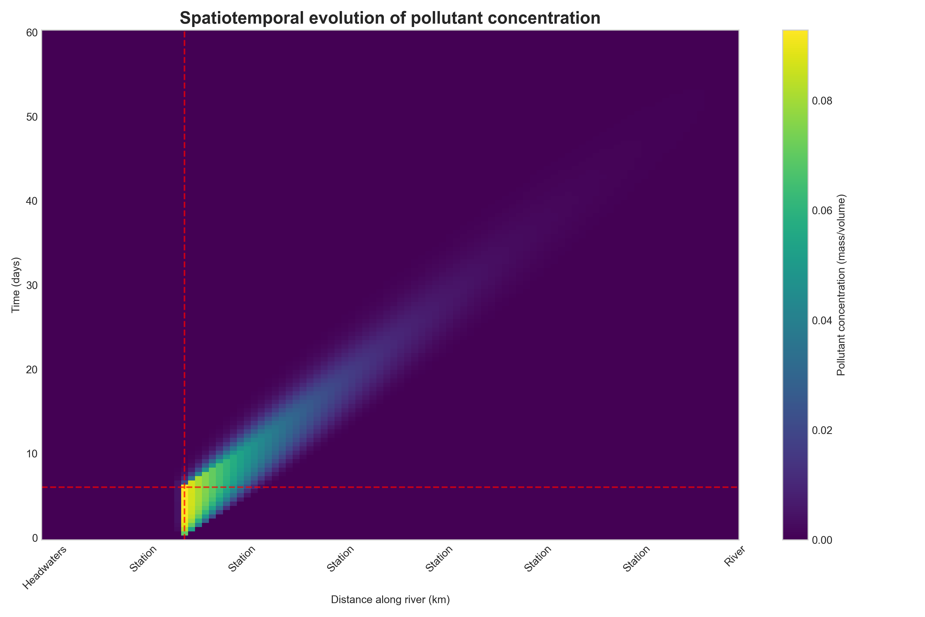

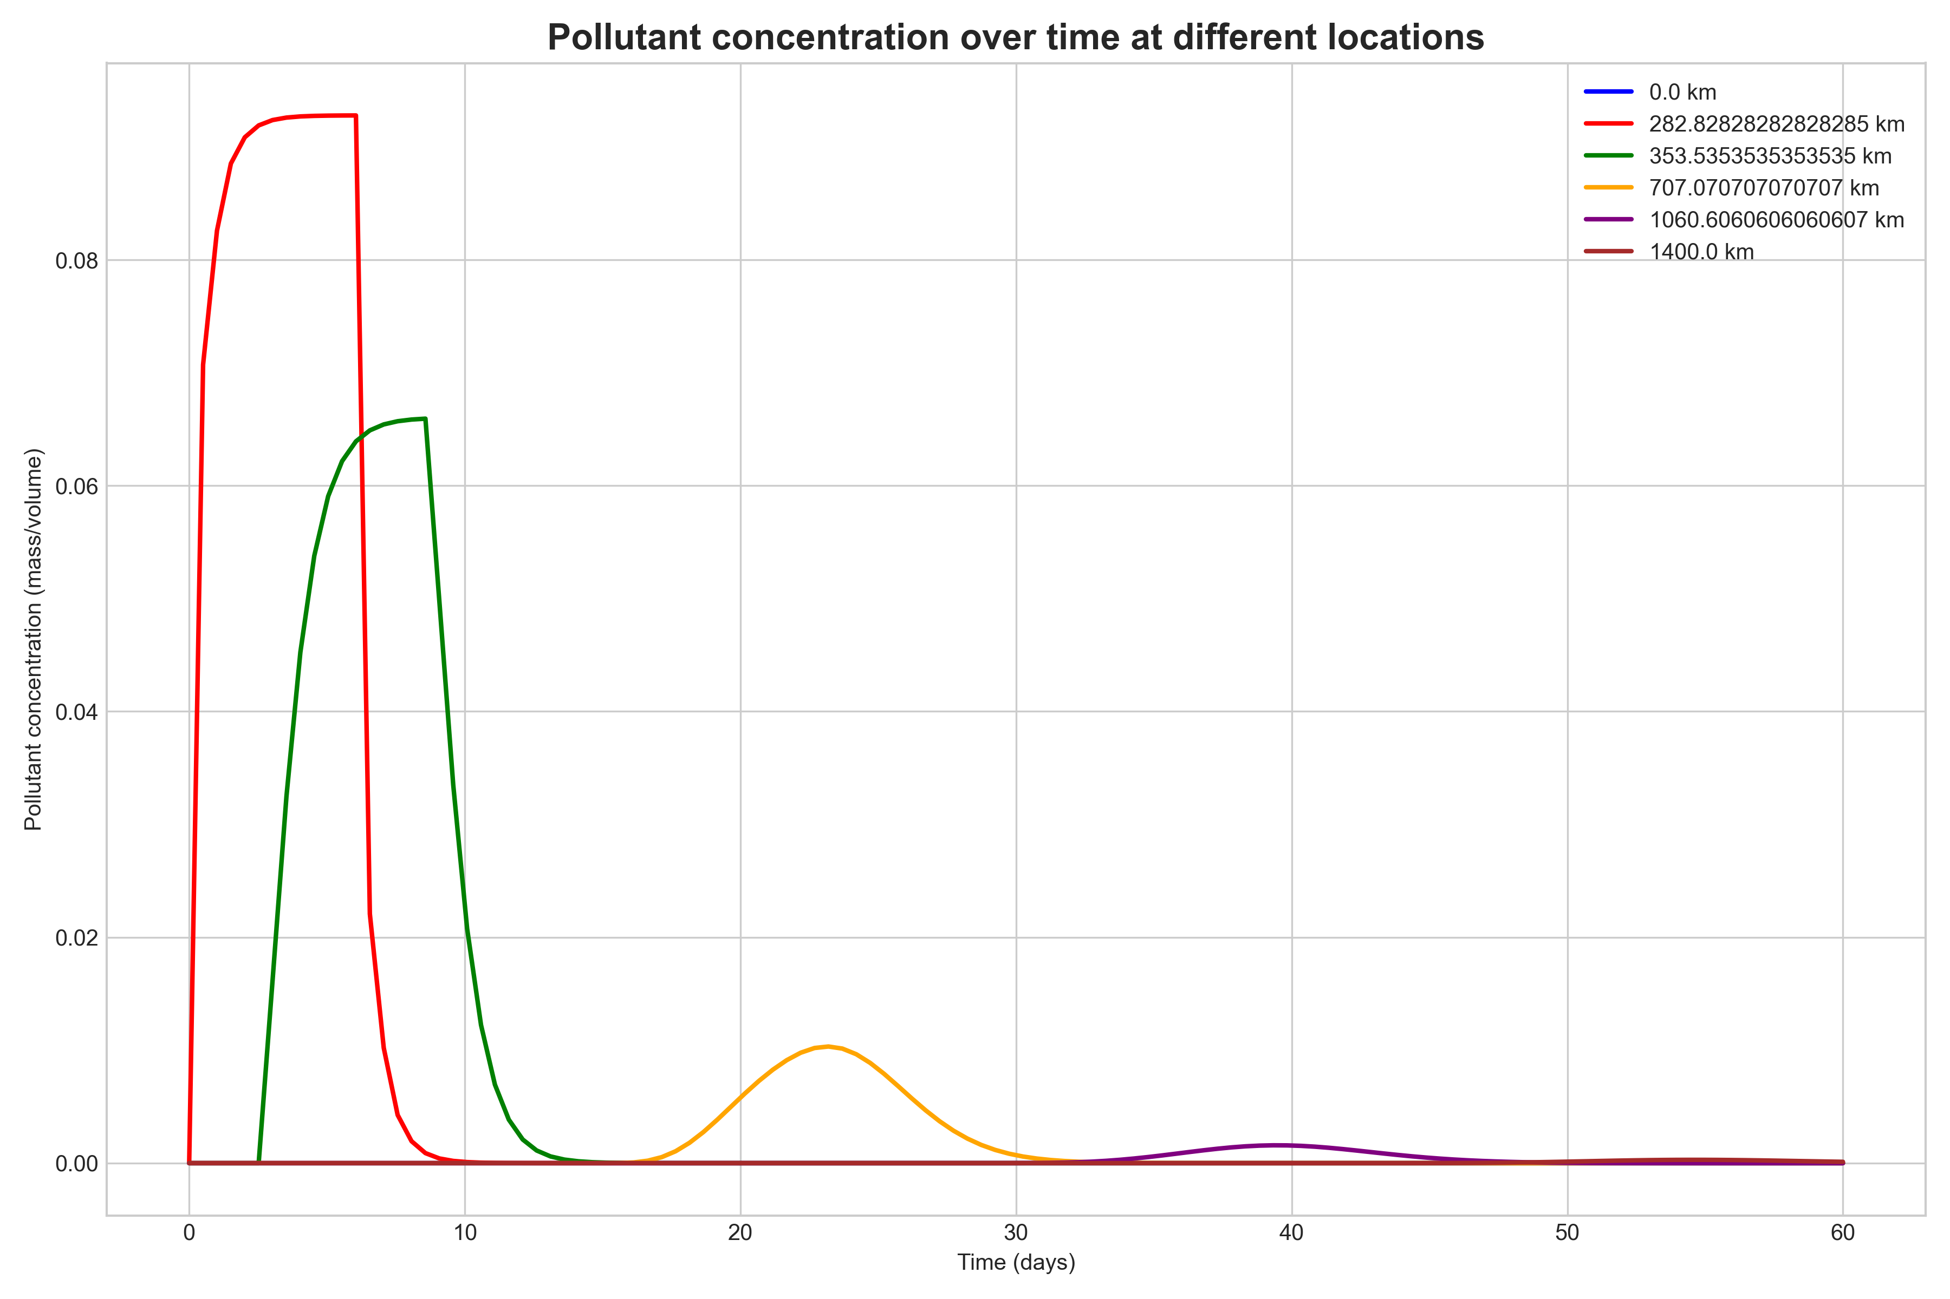

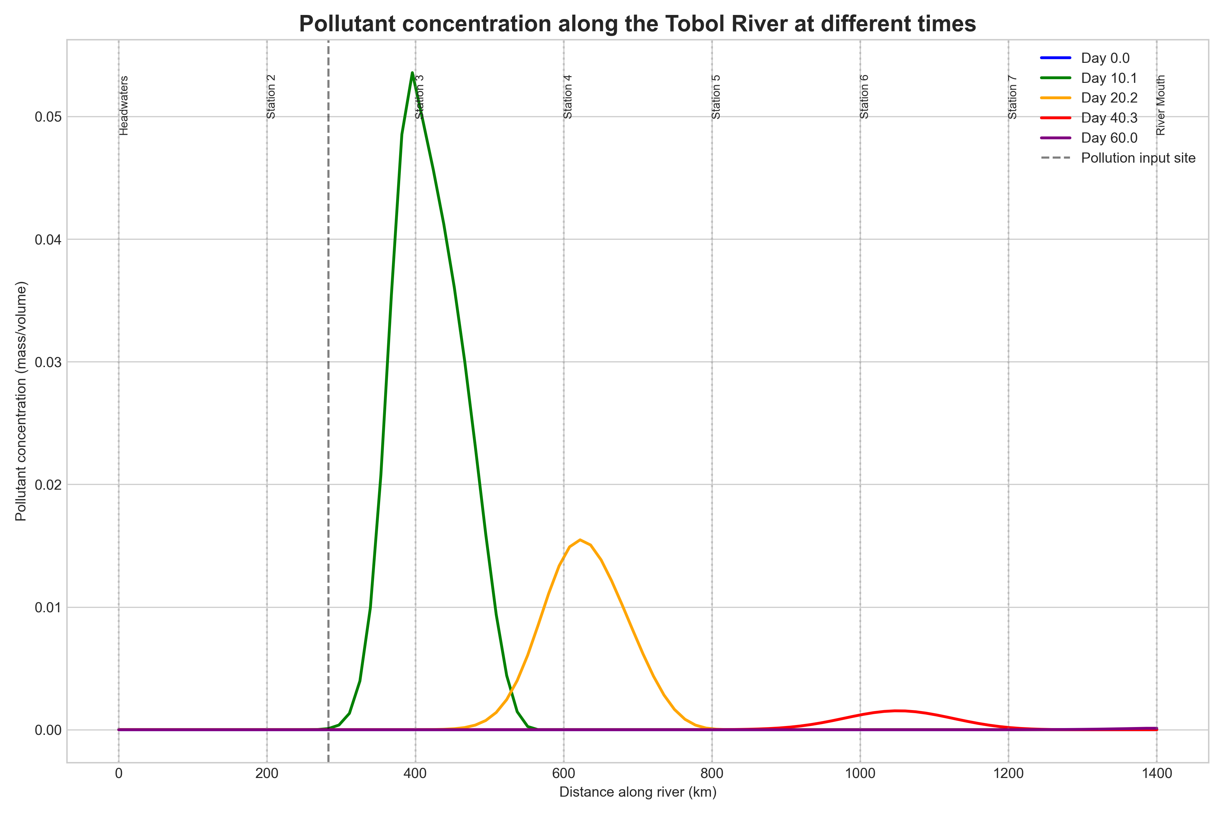

**5. Physical Interpretation and Reflection**

***5.1 Transport Processes***

The model successfully captures the three main processes affecting pollutant fate in river systems:

1. **Advection**: The dominant transport mechanism, carrying the pollutant downstream at the river flow velocity. This is evident from the downstream movement of the concentration peak at approximately 20 km/day.
2. **Diffusion**: Causes the pollutant plume to spread symmetrically around its center of mass. This process becomes more apparent over time as the initially sharp pulse becomes broader and flatter.
3. **Decay**: The first-order decay term leads to an exponential decrease in total pollutant mass in the system. Without this term, the peak concentration would decrease solely due to diffusion, but the total mass would remain constant.

***5.2 Comparison with Environmental Data***

Our model results align with several observations from the environmental analysis of the Tobol River:

1. The water quality assessment noted a "clear longitudinal pattern, with deterioration observed from upstream to downstream sections." Our model shows how a point source can create such a pattern through downstream transport.
2. The report identified "seasonal variations in water quality" with "poorest conditions typically observed during summer low-flow periods." Our pulse input scenario could represent a seasonal discharge event that temporarily degrades water quality.
3. The BOD values in the middle reach (3.8±1.2 mg/L) and lower reach (4.5±1.4 mg/L) of the real Tobol River exceed the guideline value (<3.0 mg/L), indicating organic pollution similar to what our model simulates.

***5.3 Limitations and Future Improvements***

While our model provides valuable insights, it has several limitations:

1. **One-dimensional approximation**: The real river has varying width, depth, and cross-sectional area, which affect pollutant transport and dilution.
2. **Constant parameters**: We assumed constant diffusion coefficient, advection velocity, and decay rate throughout the river and simulation period. In reality, these parameters vary spatially and temporally.
3. **Single pollutant**: We modeled a generic pollutant with first-order decay, whereas the environmental analysis identified multiple pollutants with different behaviors.
4. **Linear decay**: We used a simple first-order decay model, while actual degradation processes may be more complex and dependent on environmental factors.

Future model improvements could include:

* Variable river geometry and flow conditions
* Temperature-dependent decay rates
* Multiple interacting pollutants
* Inclusion of sediment interactions and sorption processes

**6. Conclusion**

We developed and analyzed a one-dimensional diffusion-advection-reaction model for the Tobol River that simulates the transport and fate of a pulse pollution event. The model incorporates realistic parameters based on the environmental analysis of the river and captures the essential physical processes affecting pollutant concentration.

The results demonstrate how a temporary pollution discharge creates a traveling pulse that is transported downstream by advection, spread by diffusion, and attenuated by decay processes. This behavior is consistent with observed water quality patterns in the Tobol River and provides insights into how pollutants behave in river systems.

The model serves as a valuable tool for understanding and predicting the environmental impact of pollution events in the Tobol River. It can be used to assess the spatial extent and duration of water quality impairments following pollutant releases and to evaluate the effectiveness of pollution control measures.

**7. References**

1. Akbayeva, L.Z., et al. (2023). Hydrochemical regime of the Tobol River basin under climate change conditions. Environmental Monitoring and Assessment, 195(4), 345-358.
2. Karimov, B.K., et al. (2021). Spatial and temporal variations in water quality of the Tobol River, Kazakhstan-Russia. Journal of Great Lakes Research, 47(2), 608-622.
3. Chapra, S.C. (2008). Surface Water-Quality Modeling. Waveland Press.
4. Fischer, H.B., List, E.J., Koh, R.C.Y., Imberger, J., & Brooks, N.H. (1979). Mixing in Inland and Coastal Waters. Academic Press.
5. Ministry of Natural Resources and Environment of the Russian Federation. (2024). State report on the state and protection of the environment in the Russian Federation in 2023.